

Diagnosis of Diabetic Retinopathy

25-1-R-11

**Supervisor:**

Miri Weiss Cohen

**Submitters:**

Lital Haibetov

Katrin Frimus

**Table of Contents:**

1.Abstract………………………………………………………………………3

2.Introduction………………………………………………………………...3-5

3.Related work……………………………………………………………....6-11

4.Background…………………………………………………………………..11

4.1 DenseNet……………………………………………………….11-13

4.2 Transfer Learning …………………………………………………14

5.Process ……………………………………………………………................14

5.1 Challenges …………………………………………………………14

5.2 Hyperparameters………………………………………………..14-15

5.3 Dataset……………………………………………………………..15

6.Expected achievement……………………………………………………….16

7.GUI ……………………………………………………………………….....16

8.Test Cases……………………………………………………………………17

9.References……………………………………………………………………18

**1.Abstract**

A common and severe complication of diabetes is diabetic retinopathy (DR), which affects the blood vessels in the retina and can lead to vision loss. DR occurs when elevated blood sugar levels damage retinal blood vessels, causing them to swell, leak, or close entirely. Early detection is crucial for timely diagnosis and effective treatment of DR. Routine retinal examinations, involving retinal imaging and analysis by ophthalmologists, are essential to identify lesions. However, despite the benefits of routine screenings for diabetic retinopathy (DR), these tests are not widely done in practice. Because of 3 main reasons: lack of ophthalmologists, the long period of time to analyze the retina image and lack of access to advanced diagnostic tools especially in developing countries or areas with limited resources.

In our project we intend to classify DR using deep learning method and DenseNet to develop an automated system for the prognosis of Retinal Lesions. The detection of DR will be classified by using retina image from variety public dataset.

An automated system will address the challenges and help reduce the increasing number of DR cases worldwide.

**2.Introduction**

Diabetes is a chronic condition that affects the body’s ability to regulate blood glucose levels, either due to insufficient insulin production by the pancreas or the body’s inability to use insulin effectively. Insulin is a vital hormone responsible for managing blood sugar, and its dysfunction can result in hyperglycemia (elevated blood glucose levels). Over time, uncontrolled diabetes can cause significant damage to the body, particularly to the nerves and blood vessels, leading to severe complications [5]. Globally, diabetes ranks as the fourth leading cause of death. According to the International Diabetes Federation (IDF), approximately 336 million people were diagnosed with diabetes in 2021, a number projected to rise by 7.7% by 2030[1].

Similarly, the World Health Organization (WHO) reported 422 million cases of diabetes in 2014, with estimates suggesting an increase to 522 million by 2030[2] and 600 million by 2040[3].

A common and severe complication of diabetes is diabetic retinopathy (DR), which affects the blood vessels in the retina and can lead to vision loss. DR occurs when elevated blood sugar levels damage retinal blood vessels, causing them to swell, leak, or close entirely. These changes can result in irreversible vision loss [6], and due to the absence of early symptoms, DR often progresses to permanent blindness [1]. By 2040, it is estimated that there will be 200 million cases of diabetic retinopathy globally [3].

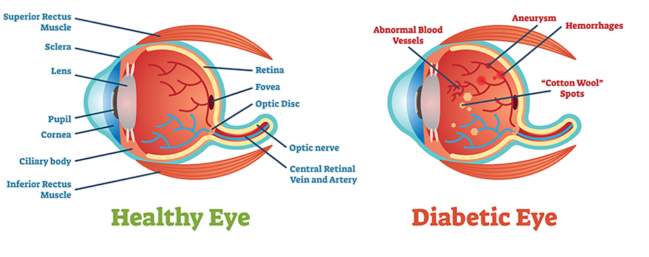  
 Figure1: Healthy eye ( left) Diabetic eye ( right)

DR is classified into five stages: normal (a), mild (b), moderate (c), severe (d), and proliferative (e)[2][Figure 2]. The early stages, known as non-proliferative diabetic retinopathy (NPDR), involve small retinal changes such as leaking blood vessels that lead to retinal swelling. Macular edema, which is swelling in the central part of the retina (the macula), is the main reason people with diabetes lose their vision. NPDR’s symptoms is blurry vision [6] while advanced stages (proliferative DR or PDR) can cause more severe retinal damage, including neovascularization and potential retinal detachment.[2]

Figure 2: Retina images from the UoA-DR dataset with different DR levels, (a) normal, (b) mild, (c) moderate, (d) severe, and (e) proliferative.

Early detection is crucial for timely diagnosis and effective treatment of DR. Routine retinal examinations, involving retinal imaging and analysis by ophthalmologists, are essential to identify lesions such as neovascularization, microaneurysms, hard exudates, cotton wool spots [3], vitreous hemorrhage and retinal detachment [2][Figure 3]. However, despite the benefits of routine screenings for diabetic retinopathy (DR), these tests are not widely done in practice. One major challenge is the time needed to analyze retinal images, which can take one to two days, delaying diagnosis and treatment [2]. In addition, there are a limited number of eye doctors who are competent to interpret these scans. Due to the increasing number of cases of diabetes, this shortage of specialists is exacerbated, placing additional strain on the healthcare system [3]. The lack of access to advanced diagnostic tools is also a concern,

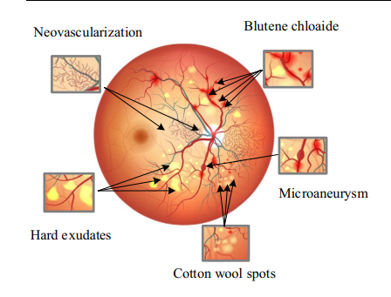especially in developing countries or areas with limited resources. Many places don’t have the equipment for regular screenings, leaving many people without proper care [2].

Figure 3: Color image and lesion magnification of the retinal

The objective of this project is to develop an automated system for the prognosis of Retinal Lesions (RL) through the implementation of a deep learning framework designed for the classification and segmentation of retinal disease patients. Upon completion, this system will provide a significant resource for healthcare practitioners.

**3.Related work**

Diabetic retinopathy detection and stage classification in eye fundus images using active deep learning [1]proposed in the article is a development of a new multi-layer architecture of active deep learning algorithms (ADL-CNN) to recognize the severity level of DR through retinography images.

The development of ADL-CNN includes preprocessing steps such as contrast enhancement and noise removal, followed by the detection of suspicious regions related to DR and classification of severity levels.

The significant advantages of the model include its ADL-based architecture, which efficiently identifies lesions associated with disease severity classification by learning visual features from images to generate masks for predictions and segment regions of interest (ROI). Another advantage is the model’s ability to detect samples, prominent parts, and lesions in images through a single backward-forward pass, learning from the most relevant image areas. Additionally, the preprocessing stage, which includes contrast enhancement and noise removal, enriches the features necessary for DR severity detection.

The effectiveness of the proposed ADL-CNN model is tested on the EyePACS dataset, containing 35k/54k high-resolution images captured under varied lighting conditions and devices. These variations in lighting and devices result in a decline in the ability to classify and segment the images accurately. Therefore, the preprocessing phase is crucial.

 Preprocessing involves converting a fundus image from RGB to the J channel of the CIECAM02 model, enhancing contrast, and converting back to RGB for normalization. Center-cropping is applied to focus on the fundus and remove black corners, followed by resizing to 48×48-pixel patches, including both normal and abnormal DR cases. Additionally, data augmentation, such as flipping and rotation, is performed to prevent overfitting, and the processed images are split into test and train sets.

The ADL-CNN model is based on the LeNet architecture[Figure 4] with 7 layers. The input consists of image patches (the relevant places of the pictures) of size 48×48×3  image. The output is a classification of diabetic retinopathy severity (normal, mild NPDR, moderate NPDR, severe NPDR, or PDR) through a SoftMax layer. The model incorporates convolutional layers, max-pooling, fully connected layers, and uses image patches to detect regions of interest and classify them.

Figure 4: A proposed active deep learning-based (ADL-CNN) architecture with fast training to classify the severity level of diabetic retinopathy.

An experiment involving statistical analysis on 54,000 digital retinal samples to evaluate the performance of the ADL-CNN was made. The metrics included sensitivity (SE), specificity (SP), F-measure, and accuracy [Table 1]. תמונה שמכילה טקסט, צילום מסך, מספר, גופן

Table 1: Performance of proposed ADL-CNN model for classification of five severity level of DR on 54,000 test images.  
E training error average standard deviation), SE sensitivity, SP specificity, Normal no diabetes, MNPDR mild proliferative diabetic retinopathy, NPDRM moderate proliferative diabetic retinopathy, SNPDR severe proliferative diabetic retinopathy, PDR proliferative diabetic retinopathy.

Compared to other models, ADL-CNN achieved the highest results comparing to other approaches, particularly in specificity (SP), sensitivity (SE), and accuracy:

It noticed that this ADL-CNN system works well in all possible severity level of NPDR as compared to comparative approaches because of the two main reasons: ADL, preprocessing.

Deep learning frameworks for diabetic retinopathy detection with smartphone-based retinal imaging systems [2] articleshowed how CNN-based frameworks like AlexNet, GoogLeNet, and ResNet50 can improve the detection of diabetic retinopathy (DR) in retina images from both smartphone-based and traditional fundus cameras.

The study utilized pretrained networks using the transfer learning approach where the last three layers from the networks were replaced with new fully connected, SoftMax, and classification layers as shown in Fig. 3(b). The classification layer has two classes since images are separated into two classes: DR and No DR.

Figure 5: Transfer learning approach for deep learning architectures.

A number of publicly available retinal image datasets were utilized in this study, including EyePACS, Messidor, Messidor-2, IDRiD, and the University of Auckland Diabetic Retinopathy (UoA-DR).

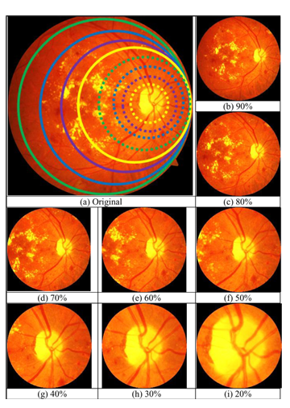

Figure 6: Comparison of the FoV of synthetic images with different percentages (0%-90%)

To evaluate the accuracy of diabetic retinopathy (DR) detection using smartphone-based retinal imaging compared to traditional fundus cameras, two experiments were conducted: one with original fundus images and another with smartphone-based synthetic images. Preprocessing was crucial due to variations in imaging equipment and issues like darkness, reflections, and low contrast. As a result, 21,502 defective images, such as those lacking a visible optic disk, were removed from the EyePACS dataset.

The final step was data augmentation, applying a vertical flip to create mirror images, ensuring complete retina coverage for more accurate DR detection. As a results **ResNet50** reached the highest accuracy of 98.6%, the sensitivity of 98.2% and specificity of 99.1%.

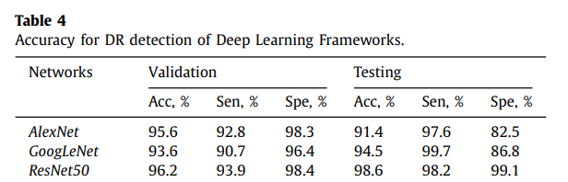

Table 2 : Accuracy for DR detection of Deep learning frameworks

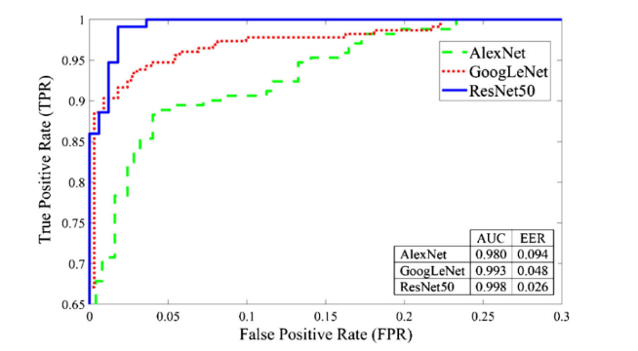

Figure 7: Performance analysis using ROC for AlexNet, GoogLeNet, and ResNet50 frameworks from original retina images.

A deep learning system for detecting diabetic retinopathy across the disease spectrum proposeddeep learning system that can detect early-to-late stages of diabetic retinopathy. [3]

The DeepDR system had three sub-networks:

1. image quality assessment sub-network: make binary classification of whether the image was gradable and recognize certain quality issues in terms of artifacts, clarity, and field problems of the retinal images.
2. lesion-aware sub-network: aim to achieve detection and segmentation of microaneurysms, CWS, hard exudates, and hemorrhages.,
3. DR grading sub-network: classify the images into non-DR, mild, moderate, severe, or PDR, and binary classification of whether there was DME.

The system was developed using a local dataset that contains a fundus image of patients with diabetes and was designed as the transfer learning assisted multi-task network.

To improve grading performance, the lesion features extracted by the segmentation module of the lesion-aware sub-network were combined with the features derived from the DR grading sub-network.

The DeepDR system achieved the whole-process diagnosis of DR from early to late stages based on the accurate detection of retinal lesions that was especially accurate for microaneurysms.

Results of the lesion-aware sub network:

Figure 8: Performance of the lesion-aware sub-network. A Receiver operating characteristic curve demonstrating the performance of the lesion-aware sub network for retinal lesion detection (n =4621). B Example images of retinal lesion segmentation: microaneurysms, cotton-wool spots, hard exudates, and hemorrhages are highlighted using green regions. Results of the DR grading sub-network:

Table 3: Performance of the Deep DR system for diabetic retinopathy grading

Classification of diabetic retinopathy algorithm based on a novel dual‑path multi‑module model [4] article proposes a dual-path multi-module network (DP2M-Net) algorithm designed to classify retinal images into DR and non-DR categories by distinguishing normal and diseased regions.

The innovative points of this algorithm are as follows:

1.The CB‑MsFU‑based data augmentation-

Differences in lighting conditions and camera types during retinal image collection may lead to significant data inconsistencies, which are addressed by using the CB-MsFU image processing algorithm to maintain data consistency

2. Dual‑path multi‑module deep network model**-**

The model first optimizes local information based on the multiplexing structure of different size kernels, and then obtains the global information of lesions, correctly reflects the locations of retinal lesions, and allows accurate DR classification with fewer medical images.

The statistical predictive results and the classification accuracy are calculated from the confusion matrix.

The proposed algorithm is evaluated on two publicly available datasets and one practical hospital dataset, namely the APTOS2019 dataset (DR1), the Messi dor-2 + EyePac dataset (DR2), and the hospital dataset. The enhanced image and the original image are used as the training data of the depth model to achieve data enhancement and reduce model overfitting.

Two experiments were conducted in this study, the first one is analysis **of image preprocessing:** It conducts comparative experiments on preprocessed and unprocessed datasets using the CB-MsFU algorithm. The results show that preprocessing significantly enhances the model’s performance in both detection and classification tasks.

DR1: DR2: Hospital:

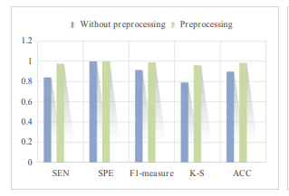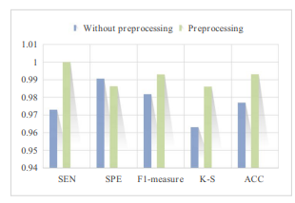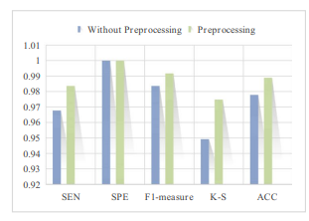

Figure 9: Comparison of experimental results with and without preprocessing.

The second one **analysis of dual‑path structure:** Combining data from dual paths improves model performance compared to a single-path approach. The dual-path model demonstrates significantly better results in detecting and classifying lesions.

DR1: DR2: Hospital:

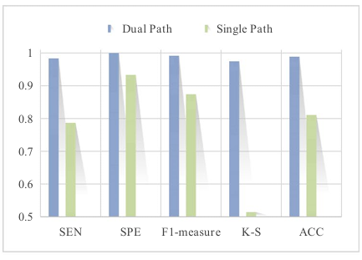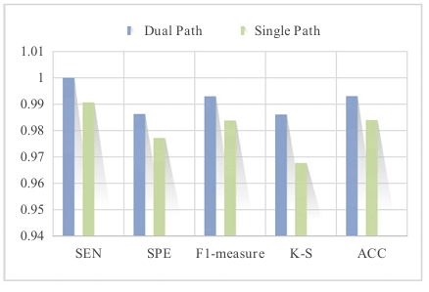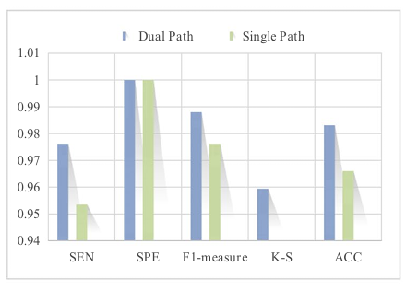

Figure 10: Comparison of experimental results for dual and single path.

The DP2M-Net algorithm achieves classification accuracies of 98.9%, 99.3%, and 98.3% for DR1, DR2, and real hospital datasets, respectively. This algorithm is both highly general and robust, and it has the potential to significantly assist doctors with the diagnosis and treatment of diabetic patients in the future.

**4.Background:**

**4.1 Dense Convolutional Network (DenseNet)**

When convolutional neural networks (CNNs) become deeper, a major problem appears information or gradients can fade as they pass through many layers. This issue makes it harder to train deep networks. Recent work has shown that convolutional networks can be substantially deeper, more accurate, and efficient to train if they contain shorter connections between layers close to the input and those close to the output.

The network has a simple connectivity pattern: to ensure maximum information flow between layers in the network.it connects all layers (with matching feature-map sizes) directly with each other. To preserve the feed-forward nature, each layer obtains additional inputs from all preceding layers and passes on its own feature-maps to all subsequent layers.

In regular convolutional networks with L layers, there are L connections, bone between each layer and its subsequent layer. In DenseNet design, there are L(L+1)/2 direct connections. the feature-maps of all preceding layers are used as inputs, and its own feature-maps are used as inputs into all subsequent layers.[7]

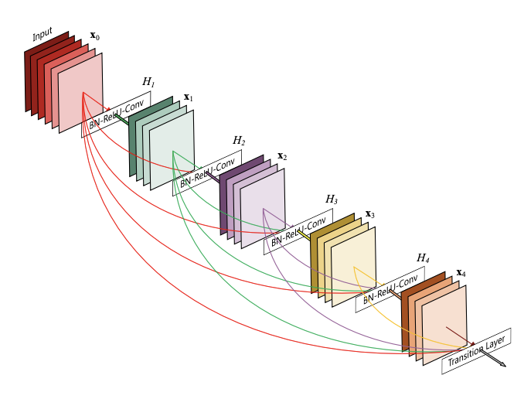

Figure 11: A 5-layer dense block with a growth rate of k = 4. Each layer takes all preceding feature-maps as input.

DenseNet is an extension of ResNet [8]. ResNet uses skip connection techniques The skip connection connects activations of a layer to further layers by skipping some layers in between [9]. ResNets make this information preservation explicit through additive identity transformations. An advantage of ResNets is that the gradient can flow directly through the identity function from later layers to the earlier layers. However, ResNets still have many parameters because each layer has its own weights.  DenseNet architecture explicitly differentiates between information that is added to the network and information that is preserved. In contrast to ResNets, DenseNet never combines features through summation before they are passed into a layer; instead, it combines features by concatenating them and containing much fewer parameters [7].

Moreover, DenseNet layers are very narrow, adding only a small set of feature-maps to the “collective knowledge” of the network and keeping the remaining feature maps unchanged—and the final classifier makes a decision based on all feature-maps in the network.[7]

Another big advantage of DenseNets is their improved flow of information and gradients throughout the network, which makes them easy to train. Each layer has direct access to the gradients from the loss function and the original input signal, leading to an implicit deep supervision. This helps training of deeper network architectures.[7]

Despite the many advantages of DenseNet, there is one major disadvantage. The feature maps of each layer are connected with the previous layer, and the data is replicated multiple times. As the number of network layers increases, the number of model parameters grows linearly, eventually leading to explosive growth in computation and memory overhead during training.[8]

DenseNet has achieved better results among many deep learning models due to the new architecture of dense connectivity. [8]

**DenseNet structure:**

The basic structure of DenseNet consists of dense block, transition layer, convolutional layer, and fully connected layer. [8]

Denseblock consists of densely connected dense units with nonlinear mapping functions of  Batch Normalization (BN) , rectified linear units (ReLU) ,Pooling  and a 3X3 Convolution (Conv), which are designed with preactivation strategy to make network training easier and generalization performance better.[8]

The process begins with a single input image x0 that is passed through a convolutional network and a Hℓ(·) that represent a composite function of three consecutive operations: BN, ReLU, Conv. The output of the ℓ th layer as xℓ Consequently, the ℓ th layer receives the feature-maps of all preceding layers, x0, . . ., xℓ−1, as input: [7]



Transition layer is the structure between adjacent dense blocks, which consists of convolution layer and pooling layer, compressing dense block input and all extracted feature information, reducing feature map size and dimensionality, which can effectively reduce the number of dense block parameters and prevent network from overfitting.[8]

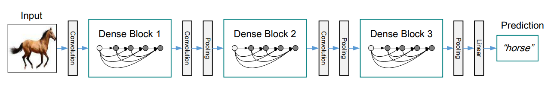

Figure 12: A deep DenseNet with three dense blocks. The layers between two adjacent blocks are referred to as transition layers and change feature-map sizes via convolution and pooling.

Another parameter of DenseNet is Growth rate each function Hℓ produces k feature maps, it follows that the ℓ th layer has k0 +k ×(ℓ−1) input feature-maps, where k0 is the number of channels in the input layer.[7]

Although each layer only produces k output feature-maps, it typically has many more inputs. To address the increasing dimensions of feature maps, bottleneck units (1×1 convolutions) and compression in transition layers were introduced, as implemented in DenseNet-B, DenseNet-C, and DenseNet-BC, reducing computational effort while preserving diverse features.[7]

In summary, DenseNet, which can learn deeper and more distinctive features from images, has been applied to several research areas of medical image analysis and has made breakthroughs.[8]

**4.2 Transfer learning:**

Transfer learning (TL) is a machine learning technique where a model pre-trained on a new relate problem. Training a new ML model is a time-consuming and intensive process that requires a large amount of data, computing power [11], and it take long time before it is ready for production. Using TL saves those resources by retrain existing models on related tasks with minimum amount of new labeled data.[10]

This process of retraining models is known as fine-tuning. transfer learning requires to isolate specific layers for retraining. There are 2 types of layers: Frozen layers and Modifiable layers. Frozen layers are layers that are left alone during retraining and keep their knowledge from a previous task for the model to build on. Modifiable layers are Layers that are retrained during fine-tuning, so a model can adjust its knowledge to a new, related task [10].

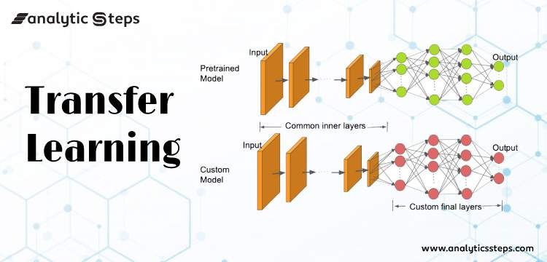

**5.Process**

**5.1 Challenges:**

One of the challenges we had was that we didn’t have medical background knowledge about DR. To understand the subject more deeply we read various professional articles and medical websites. This was something we had not dealt with before. We also faced the challenge of not being familiar with the field of deep learning such as various of neural networks. This required us to investigate the new things ourselves.

**5.2 Hyperparameters:**

The Researched hyperparameters we will research, and test in the model are as follows:

• Learning rate {0.00005 – 0.0000005}

• Epochs {50, 100, 150}

• Batch size {32, 64}

• Dropout {0.2-0.5}

Evaluation metrics

Evaluation metrics, including accuracy, precision, and recall, were adopted to compare the performances of our model and compare the performances of different methods.

TP=True positive, the model predicted that there was an existence of DR, and the retina image was correctly classified.

TN = True Negative, the model prediction was that there was no an existence of DR and the retina image was correctly classified.

FP = False Positive, the model predicted there was an existence of DR and the retina image was misclassified.

FN = False Negative, the model prediction was that there was no an existence of DR and the retina image was misclassified.

Accuracy = The relative share of the positive answer in all our parameters. The result will be between zero and one, with one being the best level of accuracy and zero being the worst.  
Accuracy=(TP + TN )/(TP + TN + FP + FN)

Precision= retina image correctly classified as DR out of all those classified as DR Precision=TP/(TP+FP)

Recall= Out of all those with a DR, the number of retina images correctly classified as a DR.  
Recall=TP/(TP+FN)

**5.3 Dataset**

Our datasets includes several databases: Eyepacs, Aptos, Messidor Diabetic Retinopathy. The dataset contain labeled images of DR levels(5 stages non- 0 to proliferative- 4). This data set, consisting of a total of 92,501 jpg files. all images have been resized to 600x600 and splitting randomly them into train (%80), validation (%10) and test (%10).  
Manual data augmentation was applied to the dataset, increasing the dataset by approximately 55%. As a result of data augmentation, the training-test and validation division was again maintained as 0.80:0.10:0.10 and the total number of images was increased to 143,669[12].

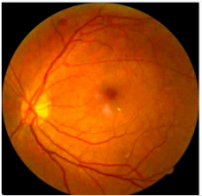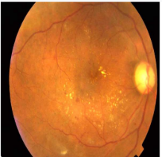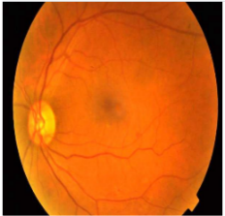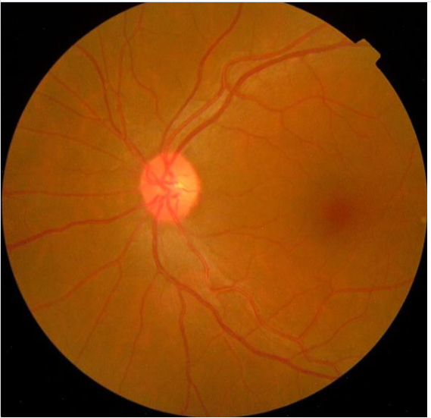

None mild moderate severe

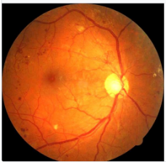

proliferative

**6.Expected Achievements**

We expect to build a deep learning model that will be able to correctly classify whether a person has DR and its type by inserting a retina image, our CNN model will be based on DenseNets, and will be trained with retina images of patients with and without different types of DR.

A DenseNet-based deep learning model for DR classification from retina images holds immense promise for detection of DR. This approach has the potential to significantly improve diagnostic accuracy and efficiency, ultimately leading to better patient outcomes.

DenseNets excel at image recognition. Our model, aiming for an accuracy range of 0.86-0.97, could surpass human interpretation limitations, leading to more definitive diagnoses.

The model's objective analysis minimizes inter-observer variability among ophthalmologist, promoting consistent diagnoses. Additionally, rapid retina image analysis significantly improves workflow efficiency, allowing for quicker treatment decisions.

Faster and more accurate diagnoses enable earlier intervention, crucial for selecting appropriate treatments and improving patient outcomes.

**7.Gui:**

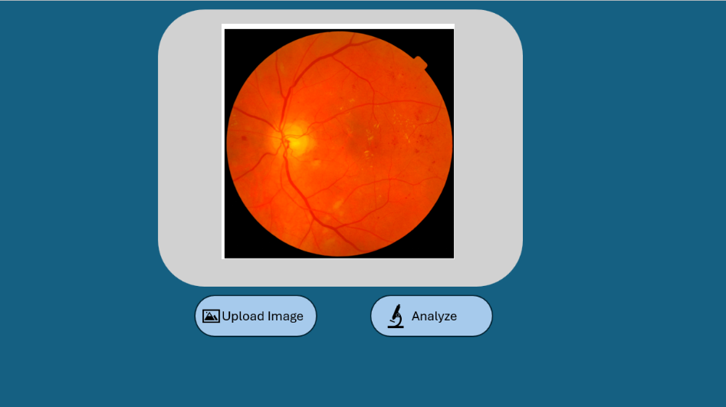

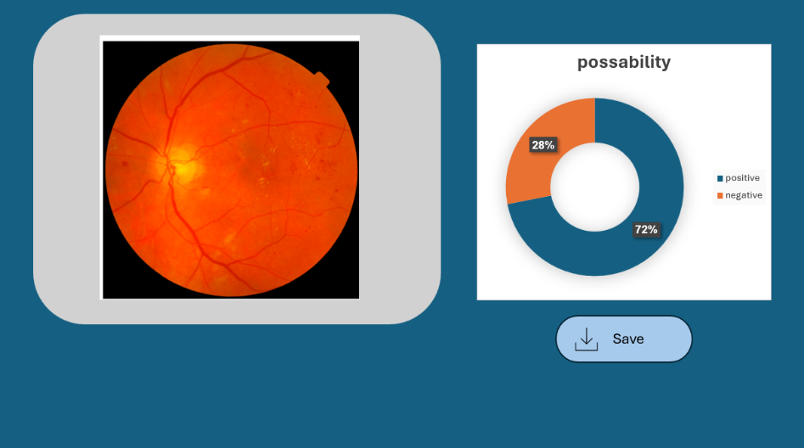

**8.Test case:**

|  |  |  |
| --- | --- | --- |
| **Expected Result** | **Case Test** | **Case number** |
| Error: "Please upload an image for analysis" | Press 'Analyze' without uploading an image | **1** |
| Error: "Invalid file format" | |  |  | | --- | --- | |  | Upload an unsupported file | | **2** |
| Image appears in the preview window | Upload a correct image format | **3** |
| The program shows percentage of possibility | Press 'Analyze' for an image with diabetic symptoms | **4** |
| Error: "File size too big " | Upload a large image file | **5** |
| Error:" Fail, try different picture" | Program fail to predict | **6** |

**9.References:**

[1] Qureshi, Imran, Jun Ma, and Qaisar Abbas. "Diabetic retinopathy detection and stage classification in eye fundus images using active deep learning." *Multimedia Tools and Applications* 80, no. 8 (2021): 11691-11721.

[2] Hacisoftaoglu, Recep E., Mahmut Karakaya, and Ahmed B. Sallam. "Deep learning frameworks for diabetic retinopathy detection with smartphone-based retinal imaging systems." *Pattern recognition letters* 135 (2020): 409-417.

[3] Dai, Ling, Liang Wu, Huating Li, Chun Cai, Qiang Wu, Hongyu Kong, Ruhan Liu et al. "A deep learning system for detecting diabetic retinopathy across the disease spectrum." *Nature communications* 12, no. 1 (2021): 3242

[4] Zhang, Lirong, Jialin Gang, Jiangbo Liu, Hui Zhou, Yao Xiao, Jiaolin Wang, and Yuyang Guo. "Classification of diabetic retinopathy algorithm based on a novel dual-path multi-module model." *Medical & Biological Engineering & Computing* (2024): 1-17.

[5] World Health Organization [link](https://www.who.int/news-room/fact-sheets/detail/diabetes)

[6] American Academy Of Ophthalmology [link](https://www.aao.org/eye-health/diseases/what-is-diabetic-retinopathy)

[7] Huang, Gao, Zhuang Liu, Laurens Van Der Maaten, and Kilian Q. Weinberger. "Densely connected convolutional networks." In *Proceedings of the IEEE conference on computer vision and pattern recognition*, pp. 4700-4708. 2017.

[8] Zhou, Tao, XinYu Ye, HuiLing Lu, Xiaomin Zheng, Shi Qiu, and YunCan Liu. "Dense convolutional network and its application in medical image analysis." *BioMed Research International* 2022, no. 1 (2022): 2384830.

[9] GeeksforGeeks [link](https://www.geeksforgeeks.org/residual-networks-resnet-deep-learning/)

[10] BuiltIn [link](https://builtin.com/data-science/transfer-learning)

[11] Amazon [link](https://aws.amazon.com/what-is/transfer-learning/)

[12] Kaggle [link](https://www.kaggle.com/datasets/ascanipek/eyepacs-aptos-messidor-diabetic-retinopathy)